**Assignment Questions- Section A**

**Q1.**

Import numpy

Define a function Create_Array () that can create an array of flexible size according to the number of arguments passed within the function call. The elements passed in the function should make the diagonal

Elements of the array and the rest of the elements can be all zeros

**For Example, if the function call is Create_Array(1,2,3,4)**

**The function shall return**

**1 0 0 0**

**0 2 0 0**

**0 0 3 0**

**0 0 0 4**

**Q2.** Write a menu based program that finds the value of a control variable 'contr' based on the following equation

contr = a + 10bc - 5d / e.

The variables a,b,c,d and e are stored in a separate file (module). The main program should terminate upon receiving 0 as input.

**options are,**

**1. Initialize**

**2. Show**

**3. modify**

**0. Exit**

**If option is 1, the module should be imported.**

**If 2, the value of all variables and that of control variable should be displayed.**

**If 3, the values should be modified by taking user input.( There should be a user defined function modify() within the module**

**If 0, The program should terminate**

**Q3.** Using the following data, draw a bar chart to show month wise High/Low temperature in Kerala state.

Months should be in X axis. There should be two bars for each month, one for High and the other for Low.

**Month Jan Feb Mar Apr May Jun Jul Aug Sep Oct Nov Dec**

**High°C 32 32 33 33 32 30 30 30 30 30 31 31**

**Low°C 23 23 24 25 25 24 24 24 24 24 23 22**

**Q3**. Create a module with name my_module to incorporate the following functions.

* **To find the sum of all numbers in a list, set or tuple**
* **To find the maximum of all numbers in a list, set or tuple**
* **To find the minimum of all elements in a list, set or tuple**

**(If the module is run as standalone script, display , “ my_module is now available” )**

**Q4.** Create a numpy 2Darray of N x N dimensions using the function ‘arange’ where N is set by the user. Define a function ‘return_diag’ into which the 2D array shall be passed as input. The function should return a linear array that would hold only the diagonal elements of the original array.

**Eg : if the array is**

**1 2 3**

**4 5 6**

**7 8 9**

**The function shall return array([1,5,9])**

**Q5.** The Experimental data for plotting input characteristics of Common Emitter Transistor Configuration is given below. Do the following using matplotlib

**Create a figure object**

**Create a subplot object**

**Plot both the graphs on the same subplot by setting line colour, line style, marker etc**

**Set X ticks and Y Ticks**

**Set X label and Y Label**

**Set Title for the plot and give proper legend**

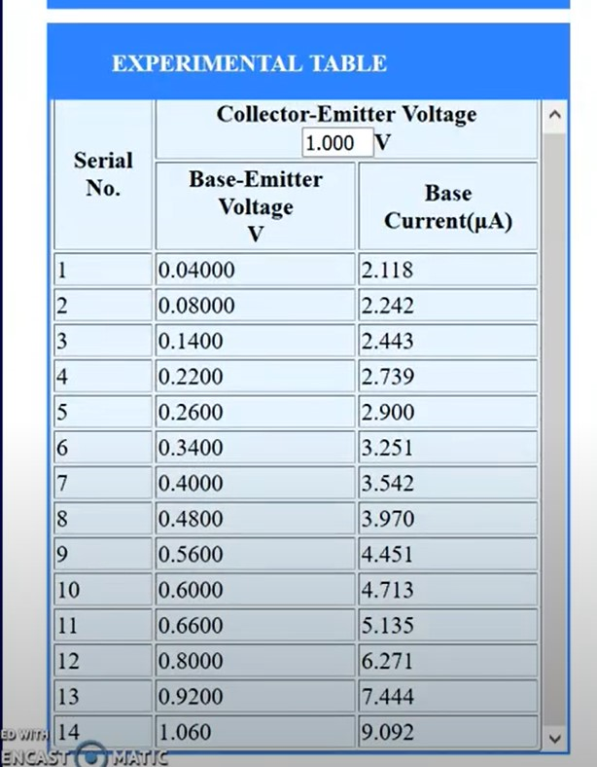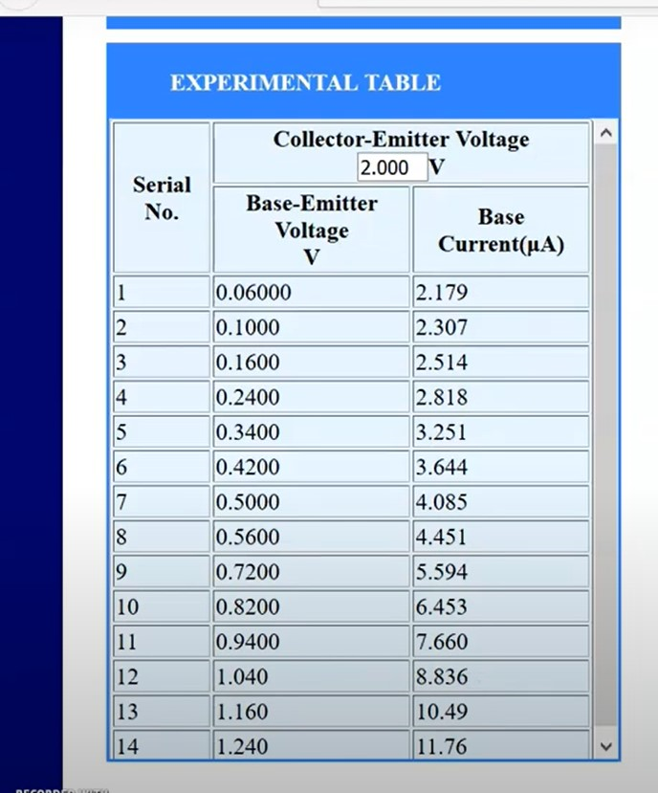

**Q6.** Show party wise seat share for following results of the Assembly Elections 2018 in

1. **Two different pie charts. Party with highest percentage should be shown as slightly detached**
2. **As a bar chart with party name on X axis and seats won on y axis. Show results of both the states on the same bar plot**

**Madhya Pradesh**

INC - Win (114)

BJP - Win (15)

Independent - Win (4)

Others - Win (3)

**Rajasthan**

INC - Win (99)

BJP- Win (73)

Independent- Win (3)

Others- Win (14)

**Q7 Write a python script to solve the following.**

A group of people took a trip on a bus at Rs.30.00 per child and Rs.46.00 per adult for a total of Rs.2488.0. They took the train back at Rs.35 per child and Rs.51 per adult for a total of Rs.2852. 0. Determine the total number of children and adults who were part of the trip. (Use numpy)